Burleson Institute’s strategy involves sharpening our focus on climate, water, energy, and governance. We are enhancing our global public interest network through a thriving array of initiatives, including expanding our open-source information sharing research and analysis.
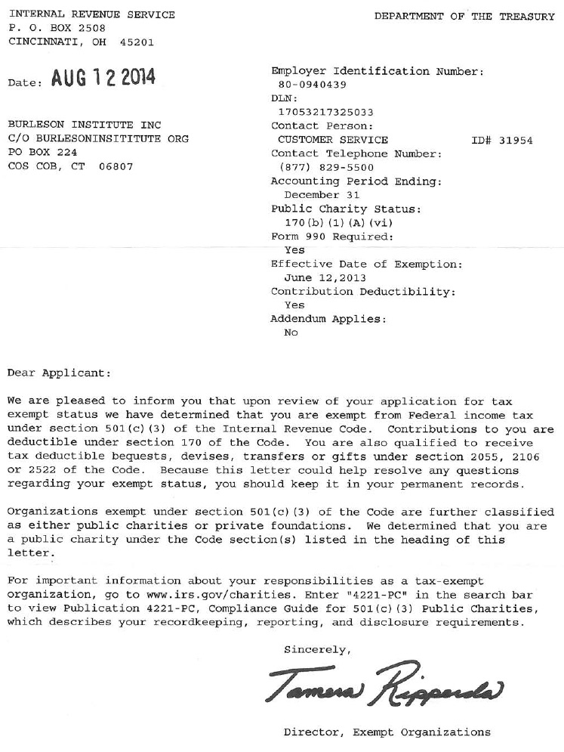
Burleson Institute is an equal opportunity organization that does not discriminate on the basis of race, gender, orientation, age, religion, ethnicity, or national origin.

Copyright and Re-publication

Burleson Institute’s Media (including both its editorial content and the code used in programming the platforms) is protected by U.S. and international copyright laws. All rights reserved. Except as specifically provided in these Terms of Use, no part of the Media may be reproduced, distributed, displayed, transmitted, stored in a retrieval system or used to create derivative works without prior consent of the copyright owner. You may copy and print content for educational, noncommercial use only, provided that you include all copyright and other notices in the content, that you do not modify the content.

To request permission from Burleson Institute for any other use, please contact B@BurlesonInstitute.org

Copyright Permission

We want you to use information you find on our web sites. Our materials are protected by copyright, but you can use information you obtain from our web sites for free for non-commercial purpose, as long as you include the copyright notice below and list the address of or link to the page where the material is found.
Burleson Institute hereby grants a non-exclusive license to any person to copy and use individual pages or portions of our web sites for non-commercial purposes, and to any member of the media for media purposes, on the condition that the appropriate copyright notice is displayed.
Example:
Copyright © 2017 Burleson Institute. Used by permission. The original material is available at http://www.BurlesonInstitute.org
Thank you for your interest in Burleson Institute’s efforts to share information. To request permission to reprint or reuse materials from our website and/or publications for commercial purposes, please address an email to B@BurlesonInstitute.org and be sure to include ALL of the following details:
- Name
- Contact information (phone or e-mail)
- Item to be reused or reprinted (please use full title and URL when possible)
- Portion to be reused or reprinted (e.g. a chart, graph, text – cite page number where possible)
- How the item will be reused or reprinted (e.g. for a presentation, for a book, for a news article, etc.
- Whether or not the reprinted information will be used for educational purposes or sold for commercial purposes
- Once we have received your request we will review it and respond within 4 business days.

Burleson Media may be reproduced in whole or in part and in any form for educational or non-profit purposes without special permission from the copyright holder provided acknowledgement of the source is made. The Burleson Institute would appreciate receiving a copy of any publication that uses this publication as a source. No use of this publication may be made for resale or for any other commercial purpose whatsoever without prior permission in writing from the Burleson Institute.

Trademarks
Burleson Institute is committed to the enforcement of its trademark rights. Use of any Burleson Institute-owned marks without permission may constitute infringement under the law and result in legal action.

Terms of Use

Burleson Institute Terms of Use and Privacy Policy apply to all Burleson Institute Inc.’s media platforms, including this website and its subdomains, websites accessed through your mobile devices, our downloadable mobile applications and Burleson Institute’s own social media sites (“Media”). By accessing and using Burleson Institute Media, you agree to be bound to these Terms of Use.

We may modify, add or delete sections of these Terms of Use at any time. Modifications, additions and deletions to these terms will become immediately, prospectively effective. Please review these Terms of Use regularly. You agree that your continued use of the Media sites following posting of updated Terms of Use constitutes your consent to any changes.

Third Party Content
Burleson Institute’s Media include links to sites and services governed by the terms set by those third parties. Burleson Institute is not responsible in any way for any third party sites, or for any products or services that may be advertised by third parties on our Media platforms. Burleson Institute does not endorse the content, operators, products, or services of these providers.

Permitted Use of Media Materials
- Any use of the Materials available through the Media must be for personal and informational purposes only, and not for commercial purposes;
- Media Materials may not be modified;
- No photographs, illustrations or other graphics, maps, videos, or graphs may be used, copied or distributed separate from the accompanying text; and
- Email addresses may not be retrieved in bulk for any reason, including commercial reasons, without specific written permission. Any rights not expressly granted herein are reserved by Burleson Institute.
Nothing contained herein shall be constructed as conferring by implication, estoppel, or otherwise any license or right under any Burleson Institute trademark. Unless expressly granted, all rights are reserved to Burleson Institute.

Posting Content to Media
Burleson Institute welcomes your participation in and contributions to its Media. By posting comments or other Materials you are agreeing to the following Terms:
- The Media is to be used solely for non-commercial purposes. You may not use the Media to publish Materials containing any advertisements or solicitations for funds, goods or services.
- You may not post Material that is defamatory, obscene, hateful, harassing, or discriminatory, or that is a violation of any law, including those protecting privacy, publicity, trade secrets, copyrights, and trademarks.
- Burleson Institute is not under any obligation to monitor the Materials residing on or transmitted to its Media; however, Burleson Institute may, at its discretion and without warning, modify, remove or reject any posted Materials for any reason, including to prevent the violation of Burleson Institute’s rights or the rights of other parties, to comply with any law, regulation or other government request, or to operate its Media sites properly.
- By posting, uploading or transmitting Material to Media sites, you represent and warrant that you are the sole owner of all rights in the posted Materials (including all copyrights) or that you have the right to license the Material to Burleson Institute for all the uses contemplated herein.
- By posting, uploading or transmitting Materials on or though Burleson Institute Media, you hereby grant Burleson Institute a worldwide, royalty-free, non-exclusive, irrevocable, perpetual, license to use, reproduce, modify, publish, publicly perform, publicly display, distribute, sublicense and create derivative works based on the Material in any form or media now known or hereafter developed for any purpose, including commercial use.
- You may not link to, post, upload, or transmit any software or other Material that contains a virus or other harmful malicious code. You may not use Burleson Institute’s media to distribute chain letters, mass mailings, or spam or to gather email addresses for the purpose of sending spam to other users.
- You must be at least 13 years old to post Materials on Burleson Institute Media.

Representation, Warranty and Indemnity
By using Burleson Institute’s Media, you represent and warrant that a) your use of the Media complies with these Terms of Use; and (b) the material you post, upload, or transmit on or through Burleson Institute’s Media does not and will not violate any of these Terms of Use. You agree to indemnify and hold harmless Burleson Institute and its directors, officers, members, employees and affiliates from any and all claims, liabilities, damages, costs, and expenses (including reasonable attorney’s fees) arising from: 1) your breach of any of the above representations and warranties; 2) your use of Burleson Institute’s Media; 3) the materials you posted, uploaded or transmitted on or through Burleson Institute’s Media platforms; and 4) Burleson Institute’s use, publication, distribution or reproduction of any such materials.

Burleson Institute’s Limitation of Liability
All content on Burleson Institute’s Media is available “as is”. Burleson Institute makes no representations or warranties, express or implied, with respect to its Media or any part thereof, including any warranties of title, non-infringement of copyright, trademark or patent rights of others, merchantability, or fitness or suitability for any purpose. In no event will Burleson Institute, its directors, officers, employees or affiliates be liable for any indirect, consequential, special, incidental, or punitive damages arising out of the use or inability to use the media.

Copyright Agent
If you believe that your work has been reproduced on Burleson Institute’s Media without permission, please contact B@BurlesonInstitute.org
and be prepared to provide:
- A description of the work you claim to be infringing and its location on Burleson Institute’s Media
- Your contact information, including your name, email address, and phone number
- A signed statement that you are the copyright owner or an authorized agent of the copyright owner, and that you have a good faith belief that the material as posted on the Media is not authorized by the copyright owner, its agent, or the law; and
- A statement, under penalty of perjury, that the information you have provided is truthful and accurate.

Applicable Law and Jurisdiction
These Terms of Use, along with the Privacy Policy, shall be governed in accordance with the laws of the State of Connecticut, without regard to principles of conflict of laws. Any dispute arising out of, in connection with, or related to these Terms of Use or your use of Burleson Institute’s Media, shall be brought in any Federal or State Court located in the State of Connecticut, and the parties hereby waive any objection that they may have to personal jurisdiction in these courts.

Copyright Notice
© 2017 Burleson Institute. All rights reserved. Some materials delivered from the Media may contain other proprietary notices and copyright information relating to those materials.

